Introduction to Cloud Computing

What is Cloud Computing?

the Cloud term refers to software and services running on the Internet, not locally on your computer

### Why Cloud Computing?

Cloud Computing evolved the ways we use a computer.

* From companies to private users, everybody relies on the cloud directly or indirectly most of the time in their daily lives.
* Nowadays, cloud-based activities are rising the Internet's capacity more than ever before. So, nearly everything in the digital world runs on cloud computing.
* It increases the value of the work and promises to reduce costs and helps users focus on their business and work rather than IT obstacles.
* It offers flexibility, data recovery, little or no maintenance, easy access and a higher level of security.

Some industries leveraging Cloud Computing are ;

* IT
* Entertainment
* Marketing and Advertising
* Artificial Intelligence & Big Data
* Biotechnology and Pharmaceuticals
* Banking
* Education
* Healthcare
* Retail
* Automotive
* Manufacturing
* Financial
* Production
* Real Estate

### How Cloud Works?

Information and data are stored on physical or virtual servers that a cloud computing service such as Amazon and it's AWS company retain and monitor. As a user of personal or business cloud computing, you use an internet connection to access the stored information on the cloud.

### Advantages of The Cloud Technology

### Cost Efficiency

* One of the most important benefits of Cloud Computing is its economy.
* Cloud computing helps to reduce a significant amount of expenditure on both capital & operational manner.
* You do not need to invest in expensive hardware, storage devices, and software, and only pay for the services you use. This also saves the infrastructure costs and the money needed to manage the network.
* It provides the companies with the lowest possible level of operation with zero data capacity and software requirements, the business can save significant capital costs.

Elastic&Flexibility

* Cloud computing helps you to reduce your resource demands and increase them according to your needs.
* For example, you can increase your resources if you have heavy traffic on your site and vice versa.
* Cloud computing gives you the flexibility to work anywhere you want, and all you need is an internet connection whenever you want.

Reliability

* Cloud computing is very reliable as the stored data is secured and can not be manipulated.
* Several copies of the data are being made, and if the database fails, the data from the other side can be recovered.
* The company can take advantage of both the vast pool of redundant IT services and the process of failover.

Increase Security

* Everything you access and save with cloud computing is on the cloud. The providers of the service pick the highest level of data protection.
* Even if a laptop is lost or damaged, another computer can be used to access the company GUI. And since all of the records are stored on the cloud, there is no question about losing important documents because they have been saved on a hard drive laptop that is now lost or damaged.
* The full-time job of a cloud host is to track security carefully, which is significantly more efficient than a traditional in-house program, where an organization needs to divide its efforts among a multitude of IT issues, with security being just one of them.

Manageability

* Cloud computing provides improved and streamlined capabilities for IT management and maintenance by central resource management.
* Many items are handled by cloud computing. The only thing the user has to do is get an internet connection and a laptop.

Availability

* By its definition, cloud computing depends on the Internet, ensuring that businesses interested in starting or extending their use of cloud-based services need to work closely with an IT consulting firm to show them how to manage bandwidth rates that will be sufficient to meet their IT needs.
* Cloud service providers offer up to 99.99% uptime to ensure that business operations and executions continue to flow.

Centralization

* All data are stored in one location.
* So that multiple remote locations can be reached.

Auto Updating

* Software updates and enhancements can be a painful thing that cloud computing simplifies for you.
* The cloud service provider looks after and controls all software maintenance and upgrades.

No maintance

* Organizations need to think about managing the entire system while operating a conventional server setup.
* A cloud computing solution eliminates the need for any maintenance.
* Not only does it increases work efficiency, but also reduces costs of operations in the longer run.

DISADVANTAGES OF CLOUD

Internet dependency

* Cloud computing requires internet connectivity as if you will not be able to access the cloud if there is no internet connection.
* There is no other way to access the data in the cloud.
* Similarly, a low-speed Internet connection makes cloud computing difficult and often impossible.

Downtime

* Cloud providers may face power loss, low internet connectivity, service maintenance, etc.
* A cloud outage is a period when cloud services are not available.
* So downtime or outage should also be considered while working with cloud computing.

Loss of control

* Since cloud computing is very secure, it still requires attention.
* In essence, you trust another party to take care of your data.
* Once you accept cloud technology, you should be well aware that you will share all the sensitive information about your business with a third-party cloud computing service provider.

Lack of Support

* Cloud computing companies sometimes fail to provide customers with adequate support.
* If you have any technical problems, you have no choice but to call the technical support of your host provider for assistance.
* You can't fix the cloud computing problems, and some companies don't provide technical support around the clock.

### Parts of Cloud Computing Architecture

Cloud Computing architecture basically comprises of the two parts which are called Front-end and Back-end. Each of the ends is connected through a network, called Internet. The diagram below illustrates the architecture of the cloud computing:

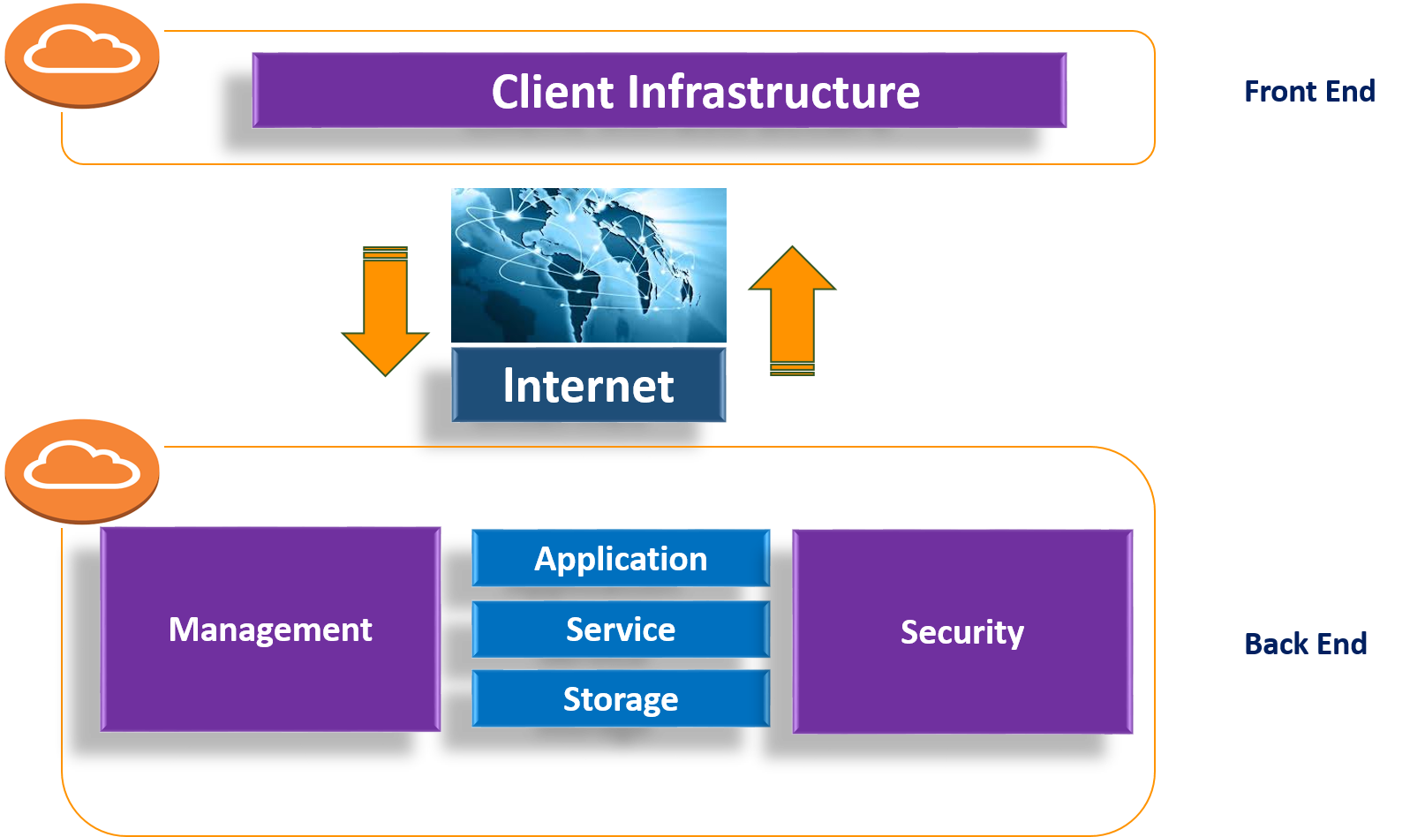

* The **Front-end** is the client part of Cloud Computing.
  + The front end is the end which is used by the user.
  + It includes the user interface and applications which are required to access the cloud computing platforms.
  + Example: Web Browsers.
* The **Back-end** refers to the cloud itself.
  + The Back-end is managed by the host.
  + It consists of all resources which are necessary to provide cloud computing services such as virtual machines, data storage, [deployment models](https://lms.clarusway.com/mod/lesson/view.php?id=775), services models, security system, etc.
  + Providing built-in security mechanisms, traffic control and protocols is the responsibility of the Back-end.